**Git2 Homework**

###### **1. Supposing that you already have a local repo with some versions in the history and a remote one on** [**GitHub**](https://github.com/) **platform (from the Git session 1 ):**

1. ***You need to add some more changes in a file from your local repository and then pass these changes to remote repo. What steps should you follow (reproduce this actions)?***

* git status
* git add .
* git commit –m “commit #3”
* git push origin master

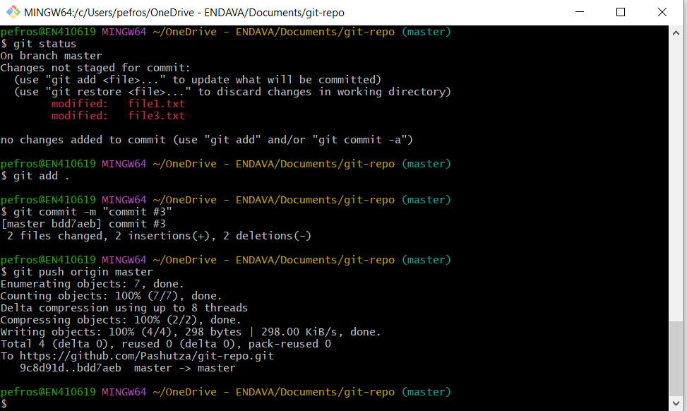

1. ***You have made a small mistake in the commit message or in a file within the previous commit which was pushed to remote and now you must make those minor corrections without “ registering” a new commit. How can you achieve that?***

* git status
* git add .
* git commit –m “commit 3” --amend
* git push origin master

I get an error, to solve it I use the command:

* git push origin master –f

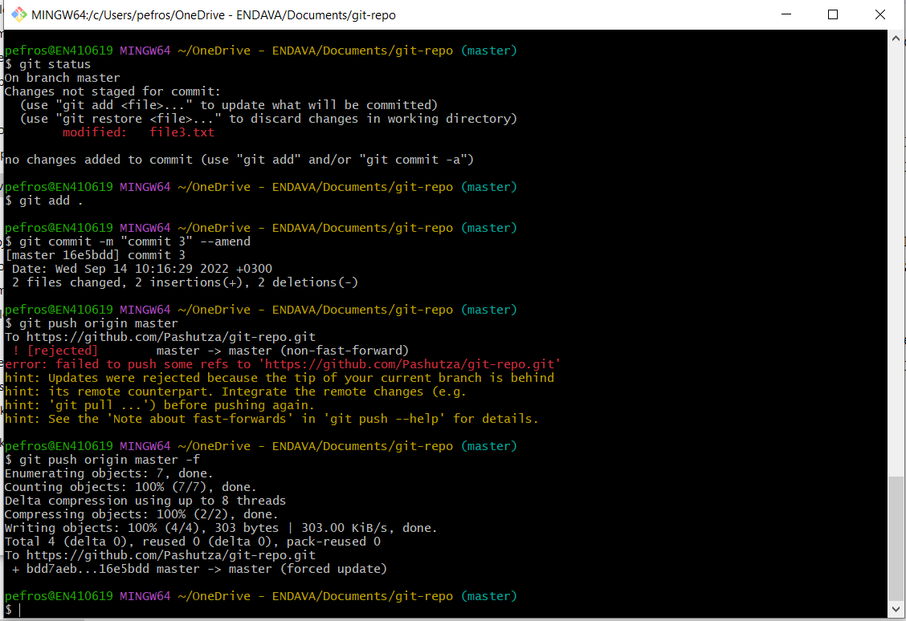

1. ***You need a new folder in your project on local repository where you will keep some local configurations secrets which should not be promoted in further commits or on remote. How will you achieve that?***

* I created a folder;
* I created a gitignore file and added the name to the folder;
* I made git bush and made the commands:
* git add .
* git commit –m “Added gitignore”;
* I added a file in the src folder to check if it is ignored.

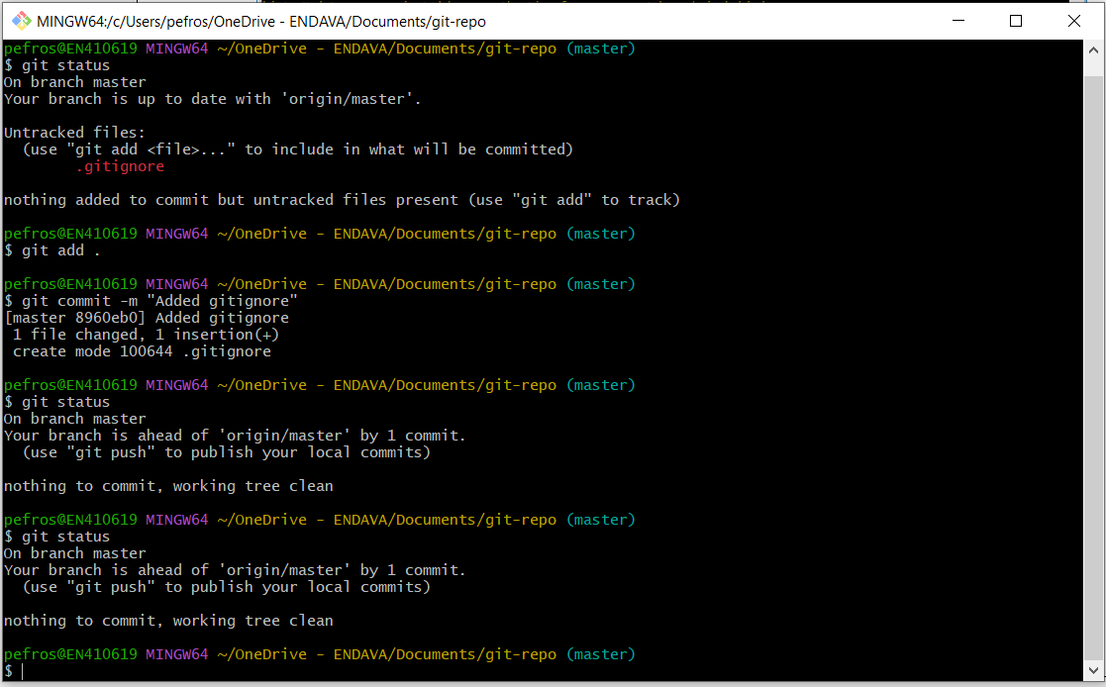

1. ***You have performed some changes in a version and have made a commit (without to push it), and then immediately you realized that there is a mistake, and an additional fix is necessary. How will you undo the commit?***

* Made some changes and made a commit;
* Applied the command:
* git reset --hard <hash of the penultimate commit >

In this way I deleted the last commit.

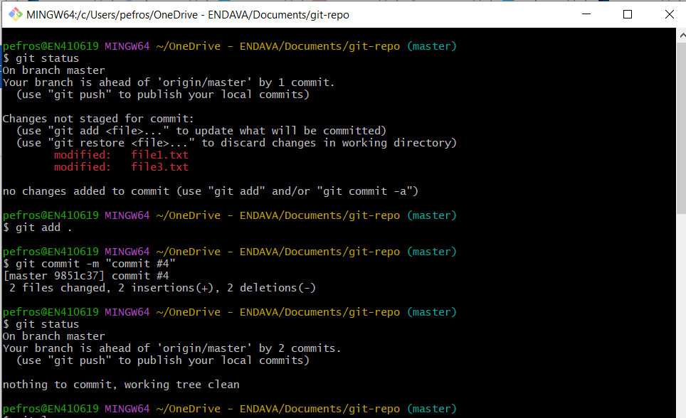

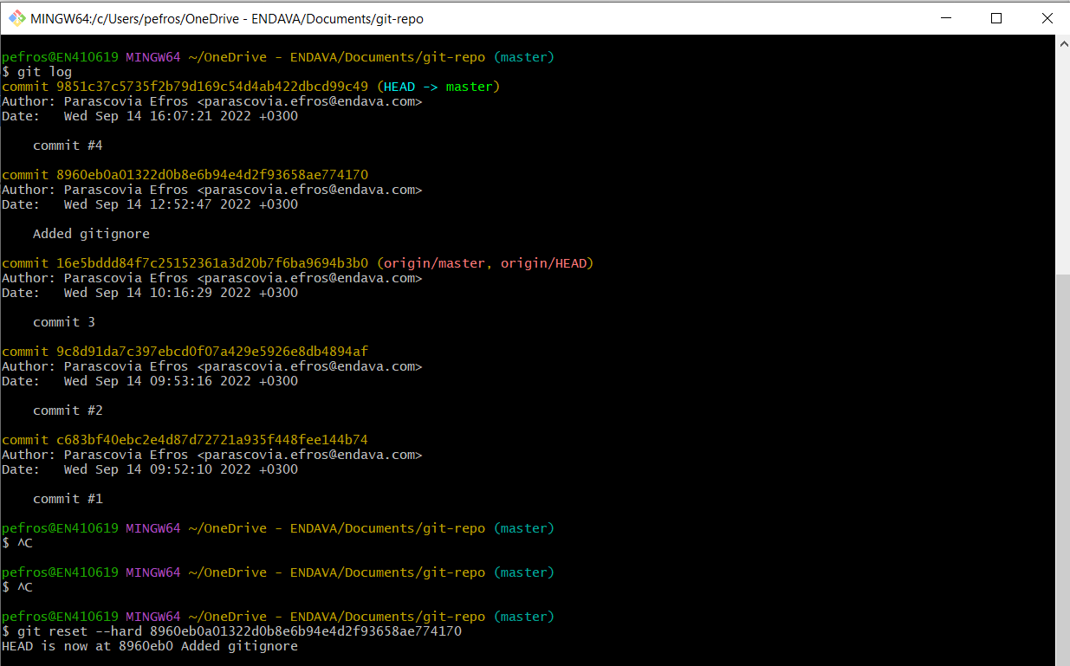

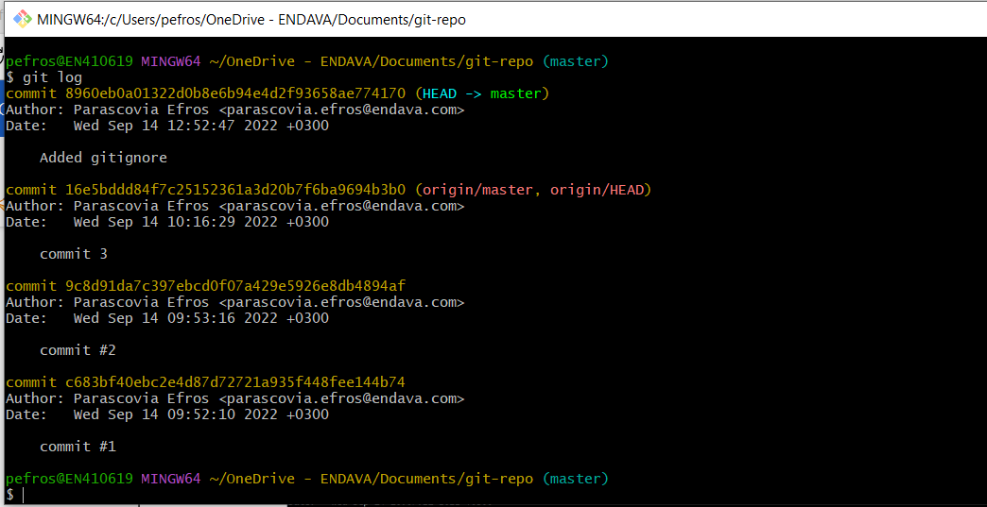

###### **2. You are a new joiner in a developing team, and in order to start working you need to recreate the project’s remote repository to your working station. What will be your actions?**

* Choose the place where we want to keep the repository and in Git Bash run the command:
* git clone <link to the remote repository >

**3. As a new joiner, you just started to work on a project which is using Git and follows a classic branching strategy. You have cloned the remote repo to a local one and need to start to work on a task. What will be your first actions?**

* Use command:
* git checkout –b <branch-name>

**4. You are actively working on a new implementation on a branch called** *feature1*. **You are asked to perform a bug fix and deliver it as soon as possible. Your actions?**

* git add .
* git stash
* git checkout <branch bug_fix>
* Fix the bug
* git add .
* git commit –m “fixed the bug”
* git push
* git stash apply <stash_name>
* Continue to work on the branch *feature1*.